Project Management Template

You can edit your own version in one of two ways:
- Edit this version to fit your needs
- Go to “File” > “Download As” > “Microsoft Word” to Download

How to Use This Template

Use this template to plan and manage your big project. We carefully crafted this template with everything you need to help your project succeed.

This project management template is broken into three segments:

- Project Plan & Analysis
- Project Status
- Project Analysis

Keep in mind, this template is designed to be completely customized by your company. You can adapt this template to meet the specific requirements of your project. If you feel there are sections included that you would rather omit, or if you think a section is missing, you are encouraged to make those changes as you see fit for your business.

Each section has italicized instructions or examples that should be deleted before completing the sections, alongside a [Bracketed Prompt] to note where the section starts.

Once complete, share it with your team for approval or send it right to your team.

Project Management Software  A simple, easy-to-use productivity tool right where you’re already working: in HubSpot’s software. |  | 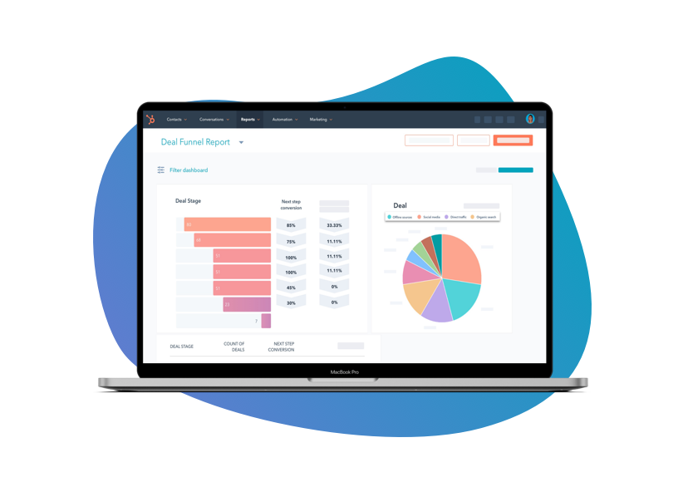
 | Learn More

Keep scrolling to template
↓↓↓
Project Plan & Outline
Overview

Introduce the key components of the project. Think about what’s needed and why you need to complete the project. What is the problem that you need to solve? Who are the main stakeholders?

[Insert Overview]

Scope

This section sets the foundation for your project and is important for gaining consensus from all stakeholders on what the project will entail. Include a broad description of all of the deliverables you will provide and every activity that will occur.

In this section, it is important to not only delineate what is required in the project but also to explain what will not be included. Include a summary of your scope in addition to a list of what the project will and will not entail. You can add more rows here by right-clicking on one of the rows and selecting “Insert row below.”

[Insert Scope Overview]

The Project Will Entail… | The Project Will Not Entail…
Example: Website Wireframing | Example: Website Animations

Objectives

List the objectives in more detail, quantifying the expected results with as much specificity as possible. Consider organizing the objectives in a table, as shown below. You can add more rows here by right-clicking on one of the rows and selecting “Insert row below.”

Objective | Measurable Impact
Example: Build a new website | Example: Improve conversions by 20%

Roles and Responsibilities

When establishing a new team, it’s important to ensure that every member understands their role and responsibilities at the outset of the project. Use a table like the one below to organize the necessary information about all of the team members. You can add more rows here by right-clicking on one of the rows and selecting “Insert row below.”
Team Member | Role | Responsibilities
Example: Ryan Johnson | Example: Developer | Example: Coding, Deployment

Project Deliverables

List the specific deliverables that will be completed by the end of this project. Provide a brief description of each and note who from the project team will be in charge of providing it. Arrange this information in a table like the one below. You can add more rows here by right-clicking on one of the rows and selecting “Insert row below.”

Phase | Task/Deliverable | Start Date | End Date
Example: Planning | Example: Wireframe for Website | Example: 10/1 | Example: 10/15

Budget

Using the set of deliverables and tasks that you outlined in previous sections, calculate the cost of each item. The structure of your budget will vary based on the type of work you do, but the table below can be used as a starting point. You can add more rows here by right-clicking on one of the rows and selecting “Insert row below.”

Budget Item | Rate | Quantity | Total Cost
Example: Website Design | Example: $200/hr | Example: 20 Hours | Example: $4,000
Total |  |  | Example: $4,000

Project Status

Date Last Updated: [Insert Date]

Status Overview

Provide a status project update summary for the reader. Overall, has the project timeline, scope, or budget changed? Are you still on track, and if not, why?

[Insert Status Overview]

Status Tracker

Provide a status update summary for the reader. Overall, has the project timeline, scope, or budget changed? Are you still on track, and if not, why? You can add more rows here by right-clicking on one of the rows and selecting “Insert row below.”

Task/Deliverable | Due Date | Status | Notes
Example: Wireframe for Website | Example: 10/15 | Example: Complete | Example: Link to outline here
Example: Desing | Example: 11/30 | Example: On Track | Example: V1 delivered on 10/30
Example: Animation Codes | Example: 12/30 | Example: Blocked | Example: Delayed due to lost vendor. Investigating a new path and will update.

Budget Status

Provide a status update on budget. Are you still on track, and if not, why? You can add more rows here by right-clicking on one of the rows and selecting “Insert row below.”

Line Item | Planned Cost | Current Cost | Under/Overage
Example: Cost #1 | Example: $10,000 | Example: $10,000 | Example: $0
Example: Cost #2 | Example: $20,000 | Example: $10,000 | Example: -$10,000
Example: Cost #3 | Example: $10,000 | Example: $12,000 | Example: $2,000
Total |  |  | Example: $8,000 Under Budget

Project Analysis

Summary

Summarize the project process. Explain the wins, losses, and learnings from this project that should be noted for future assignments.

[Insert Summary]

Project Successes

Provide a status update summary for the reader. Overall, has the project timeline, scope, or budget changed? Are you still on track, and if not, why? You can add more rows here by right-clicking on one of the rows and selecting “Insert row below.”

Success | Explanation
Example: Coming in Under Budget | Example: We came in 6% under budget on this project, which will be reallocated to new team projects for the end of the year.

Project Failures

Provide a status update on budget. Are you still on track, and if not, why? You can add more rows here by right-clicking on one of the rows and selecting “Insert row below.”

Failure | Explanation
Example: Missing Deadline | Example: We missed the deadline by two weeks, which hindered our ability to meet our goal for website views for the year.

Project Learnings

Provide a status update on budget. Are you still on track, and if not, why? You can add more rows here by right-clicking on one of the rows and selecting “Insert row below.”

Learning | Explanation
Example: Communicate More | Example: Had we communicated with vendors and stakeholders more, we likely would have stayed on track to meet our deadlines.

Appendix

The appendix is a good place to include any information that you think is important, such as price quotes and contracts. You can reference them in the project plan and attach them here so that they do not interrupt the flow of the narrative.

[Insert Appendices]

